Protein Structure Alignment by Incremental Combinatorial Extension (CE) of the Optimal Path
Ilya N.Shindyalov and Philip E.Bourne
Protein Engineering, Vol. 11, No. 9, pp. 739-747, 1998
Abstract

- Introduction
A new algorithm is reported which builds an alignment between two protein structures. The algorithm involves a combinatorial extension (CE) of an alignment path defined by aligned fragment pairs (AFP) rather than the more conventional techniques using dynamic programming.

1 YKARNKLTGEVVALK…KIRLDTETEGVPSTAIR 100
1 VVRKARNKLTGEVVA…LKKIRLDTETEGVPSTI 150

 | 1 | 2 | … | 142
1
2
…
92

(1,17) has 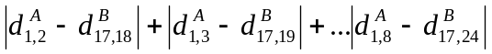
- CE algorithm
Search for high scoring (modified distance difference on relevant sub-matrix) sets of AFP paths.

Input：positions in proteins
Output：alignment as correspondence c between subsets

- Start with set containing path of single AFP.
- Repeat：choose path, choose new AFP(s) with which to extend it, add resulting path(s) to set if good enough.
- Score (new) < threshold₁?
- For each old AFP on path, score (old + new) < threshold₂?
- Score (entire path) < threshold₃?
- Terminate when no good-enough extension.
- Test statistical significance.
- Iteratively improve best alignments by pushing gaps up to +-m/2 positions away and increasing alignments length.

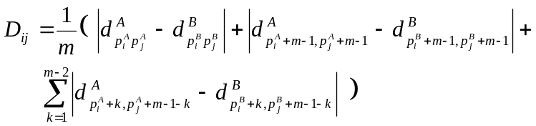
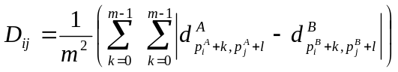

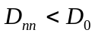
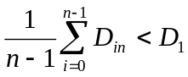
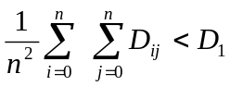

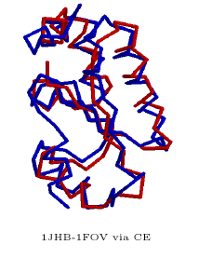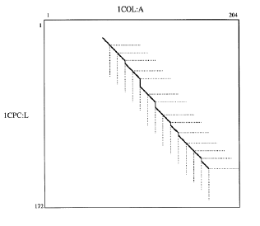
Created by : Rei-Sing Cheng
Date : Aug. 15, 2002

